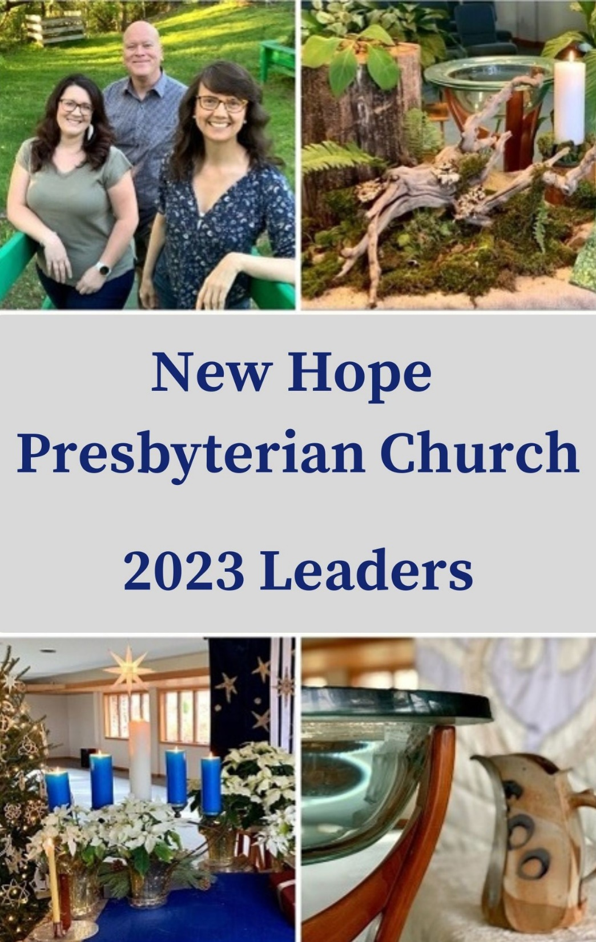
New Hope
Presbyterian Church Leaders Guide
2024

New Hope Presbyterian Church
We are a welcoming, inclusive faith community, seeking to respond to Christ’s call to love and serve, through ministries of compassion and social justice.
3070 Sweeten Creek Road, Asheville, NC 28803 | (828) 274-0191
www.newhopepcusaasheville.org

Rob Blackwell, Director of Music Ministry
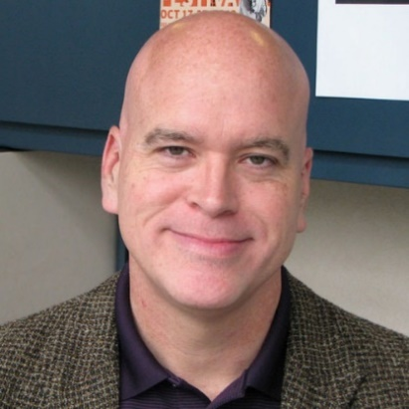
Rob Blackwell received his Bachelor of Music in Piano Performance from Ohio State University. He is currently both the pianist for Cantaria and is a Musical Director for the Asheville Community Theater, having led over a hundred musical productions in the U.S. and abroad. He has also served as a vocal coach in both Philadelphia and New York. Prior to joining the staff at New Hope, Rob served as the pianist at Jubliee Church. He would love to talk with you about joining the choir or playing your instrument in worship! Contact Rob at rlblackwell@hotmail.com. ​

Session Elders/Committee Leaders
Terri Carpenter (Class of 2025), Finance & Administration
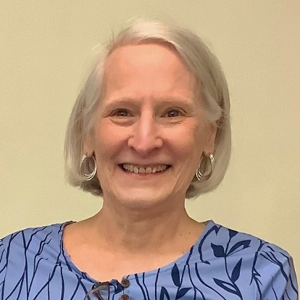
Terri is a lifelong Southerner who, along with her husband Bill, moved to Asheville in 2015 to be closer to their daughter and to enjoy the beautiful Blue Ridge Mountains. After retiring from Fidelity Investments in 2017 following a long career in IT, Terri loves the gift of time afforded by retirement and is filling it by hiking with Bill, cooking, and volunteering. Though not raised in the Presbyterian Church, Terri has been a faithful member of the denomination for almost fifty years and is looking forward to serving as an Elder at New Hope. Contact Terri at terri.q.carpenter@gmail.com or (704) 400-5409.
Woody Ferrell (Class of 2025), Congregational Life
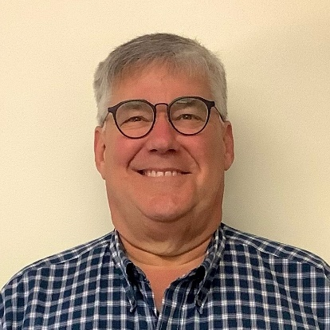
Woody was born in March of 1963 in Winston Salem, NC. He has lived in this incredible state, from Asheville to Cape Lookout Lighthouse on the coast. He and Janet met in college
in 1979 and were married at West Asheville Presbyterian Church in 1983. They moved back to Asheville in 2000 and joined New Hope Presbyterian Church. As a young child, Woody attended St. Paul’s Episcopal Church in Winston Salem. He spent his summers on the coast of NC at Camp Morehead as a camper and then as a counselor. He enjoyed working with the youth, building lifelong friends, and participating in Sunday morning chapel and evening vespers. At the age of 15, he was diagnosed with Dyslexia, a learning disorder, and headed off to The Gow School in South Wales, NY. It was an incredible experience for him to live on campus with only 114 students. Worship services were held every Sunday, and as a student he participated in services held at the very small chapel on campus. After serving in the United States Coast Guard, Woody attended North Carolina State University and earned a BA in Business Management. He worked in the heavy equipment industry throughout his career. After moving back to Asheville, he worked for Volvo Construction Equipment and traveled extensively. He is currently employed by Vermeer Corporation. Contact Woody at woody.ferrellNC@gmail.com or (828) 412-2495.
Virginia Hebert (Class of 2024), Outreach
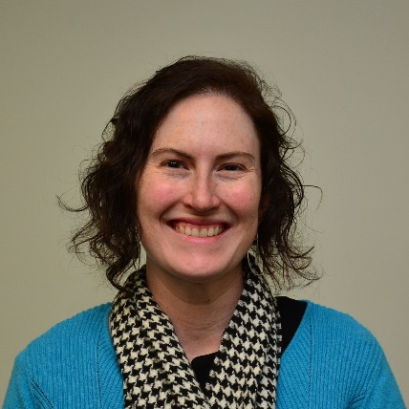
The daughter of an army officer and a K-6 teacher, Virginia is originally from “nowhere in particular” but has called North Carolina home off-and-on since 1997. A graduate of North Carolina State University and the University of the District of Columbia School of Law, she has dedicated her professional life to public service, most recently as an assistant public defender for Buncombe County. Thrilled to have landed in Asheville, she enjoys exploring the hiking trails of Western North Carolina as well as reading and hanging out with Raleigh, her mischievous chocolate lab. Finding an immediate home at New Hope, Virginia is excited to share with its members her passion for dismantling oppression. Contact Virginia at vlhebert@gmail.com or (919) 264-4407.
Susan Maveety (Class of 2024), Outreach
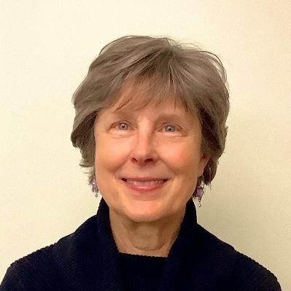
Susan and her husband have been members of New Hope since 1987. She graduated with a degree in business and economics, but many years later attended UNCA for her teaching certification. After a career as a high school math teacher, Susan now serves as Co-Moderator of the PW Microloan Task Force. Before Covid, she volunteered at the Habitat for Humanity ReStore and the Swannanoa Correctional Center for Women. Now she spends her free time helping her grandson with virtual learning. She cannot wait to get back to her volunteer routine and visiting our sister church in Guatemala. Susan is married to Jay and they have two married adult children and two grandsons. Contact Susan at susan.maveety@gmail.com or (828) 768-5475.

Staff
Kim Wells, Pastor
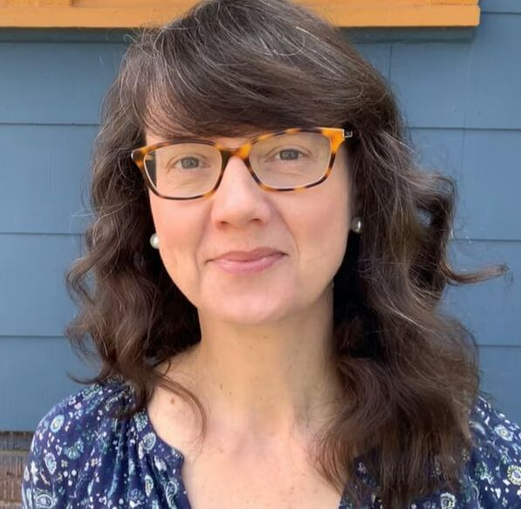
Kim has been the pastor of New Hope since the fall of 2016 and is so grateful to be in ministry alongside the people of this congregation. Having been raised from early childhood in the San Francisco Bay Area, Kim completed her B.A. at the University of California, Berkeley and her M.Div. at Princeton Theological Seminary. In addition to her ministry at New Hope, Kim serves as chair of the board of the Asheville Poverty Initiative. Kim enjoys frequenting the shops and walking in her West Asheville neighborhood, working in her garden, making mosaics out of salvaged and foraged items, and vacations that involve tide pools and echinoderms. Contact Kim at pastornhpc@gmail.com or (828) 274-0191.
Erin May, “The Hub” (Church Administrator)
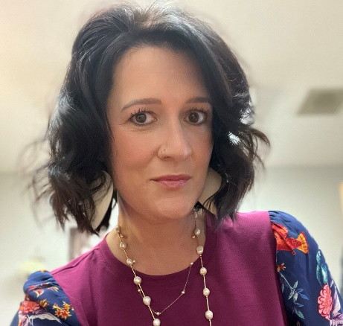
Erin is raising two children with her husband, Darrin, who is the air traffic manager at Asheville Regional Airport Control Tower. Before moving to Asheville, Erin and her family previously lived in Elmira, New York, where Erin worked in a similar administrative role at The Park Church, a UCC congregation. Erin said that what she enjoyed most in that position was getting to be “the hub” of all the church’s administrative activities. Drop by and see Erin during church office hours, Tuesday-Friday, 9 AM-2 PM, or contact her at officenewhope@gmail.com or (828) 274-0191.

Nominating Committee
Our 2024 Nominating Committee is made up of one elder, one deacon, and one at-large member (Margaret Marsh, below).
Nan Riley
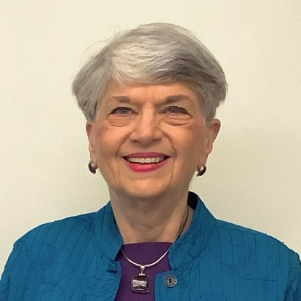
Having grown up in Charlotte as the daughter of a Presbyterian minister, Margaret is a lifelong Presbyterian. Before moving to Asheville in 2017 with her cats Brother and Sadie to be near her son, she lived for many years in Decatur, Alabama. While there, she worked for years as the administrator for low income housing for the elderly, something she always felt was a ministry. In her church, she served as an elder, taught Sunday school, was actively involved in Presbyterian Women, and served on the Presbytery’s Committee on Ministry. Outside of church, she worked with the library’s Friends of the Library as a board member and was actively involved in the Rotary Club. She enjoys traveling, playing bridge, reading, and being near her family. In addition to her son in Asheville, she has a son in St. Petersburg, FL. She is so glad to have found New Hope and looks forward to serving on the Session. Contact Margaret at margaretmarsh@bellsouth.net or (256) 565-8075

Barbara McLean (Class of 2026), Personnel
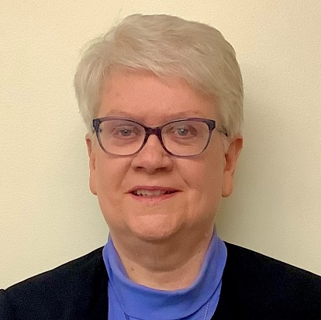
A lifelong Presbyterian, grew up in a clergy family. Having graduated from Lenoir High School, she completed degrees in piano and music education at St. Andrews Presbyterian College. After teaching, she began working as a medical manager and ended her career as Director of Pediatric Outpatient Services at Mission Hospital. Barbara has served the PC(USA) in numerous leadership roles—as an Elder, Clerk of Session, Moderator of the Presbytery of Western North Carolina (PWNC), and Moderator of Presbyterian Women (PW) in the PWNC. Barbara was also on the PWNC’s Committee on Ministry (COM) for six years, serving as the liaison to the Pastor Nominating Committee that brought Kim Wells to New Hope. She also participating in COM’s examination of Kim. In addition to these roles, Barbara was also Chair of the Board for the Irene Wortham Center and The Children’s Center at Grace Covenant Presbyterian Church. Contact Barbara at bmclean379@gmail.com or (828) 254-1034.
Andy Morse (Class of 2026), Worship
Andy grew up in New Jersey, attending various churches and youth groups. He went to college in New London, CT, where he majored in German and was active in music programs, jazz ensembles, etc. His German studies lead him to the master’s program at Indiana University in Bloomington where he met Elaine. They both spent time in Germany on exchange fellowships. After receiving their degrees, they moved to Atlanta where they followed career paths in Information Systems in the retail, finance, distribution and health care industries over 40 years. They both retired and moved to Asheville to enjoy the cooler climate and slower pace of life. He became active in church again in the late 80s in Atlanta at a “liberal” Baptist church in East Lake, then a PC USA church near their home in Tucker GA where he was on session twice, and a United Church of Christ church close to them in the Emory Area, where he was a deacon. He always sang in the choirs. In addition to ensemble singing (when it’s possible) he enjoys hiking, photography, and American Sign Language. Contact Andy at andy.morse.314@gmail.com or (678) 428-2129.

Jean Moxley (Class of 2024), Justice & Reconciliation
Jean spent her early years in Commerce, Georgia where the Presbyterian Church was a big part of her life. In her first marriage she lived and taught in New Orleans and Okinawa where she met people who expanded her view of the world and God’s love. She moved to Greensboro, NC where she was active at First Presbyterian Church. Teaching at the elementary level was her calling. After 9 years of raising two daughter alone, she met and married Russ and added 4 step-daughters to her family. She and Russ enjoy living in Asheville and visiting 12 grandchildren in Texas and NYC. Jean spends her time hiking, doing yoga, making new friends and learning new music to share with her harp. Contact Jean at jeanhmoxley@gmail.com or (336) 324-3111.

Nan Riley (Class of 2026), Congregational Life
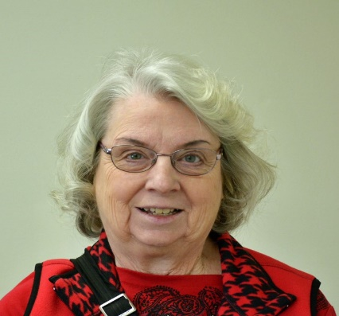
Nan is a life-long Presbyterian, who moved to Asheville in 2011. She grew up in Gainesville, Florida, where her mother worked as a secretary at their church for 10 years, and where her father worked at the University of Florida. She met her husband, John, while they were both students at the University of Florida. She has fond memories of coming as a young child to Montreat, where her grandfather had a home. She returned to this area as a teenager to attend youth conferences at Montreat and leadership conferences at Blue Ridge Assembly. She and John spent several days of their honeymoon here, and later brought their sons here for vacation. Nan is a recently retired Nurse Practitioner, having been a Registered Nurse for 50 years and a Nurse Practitioner for 40+ years. Her husband is a retired Presbyterian minister. They raised three sons while he was serving churches in Virginia, Pennsylvania, and West Virginia. Nan enjoys gardening, sewing and crafting. You can contact Nan at revjohnanfnp@aol.com or (828) 775-7444.
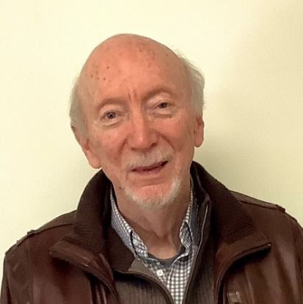
Cal Reid (Class of 2026), Deacon
​Cal Reid was raised in North Carolina and belonged to an historic Presbyterian Church outside of Charlotte, where several generations of his family had worshiped. He met his wife, Elsie, while attending college, and they both moved to the Washington, D.C. area to continue studies and work. In late 2014 Cal retired from a privately held engineering and construction firm as a senior principal engineer. Just before leaving Maryland, Elsie and Cal celebrated their 50th wedding anniversary. For forty years they were members of Potomac Presbyterian Church, where Cal served as Elder, Deacon, and Stephen Minister. He continues to participate in science and religion discussions and the men’s book club with his friends from Potomac. Interspersed with travels to see the grandchildren in California, Cal is currently struggling to teach himself fingerstyle guitar. Contact Cal at clreid07@gmail.com or (301) 466-6341.

Karen Ward (Class of 2025), Deacon
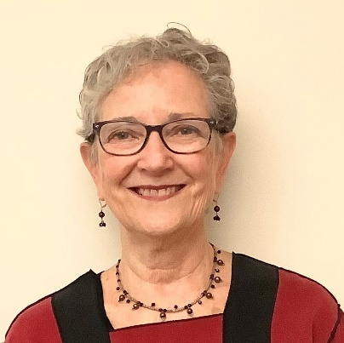
Karen was born and raised in Dayton, OH, and was very active in her Methodist church there. She went to nursing school in Cincinnati and worked there after graduation. After living in Miami for 2 years, she took off for the west coast, living in San Francisco for 43 years. There she became active in the Presbyterian Church for 37 years, singing in the choir, serving as a deacon and an elder, assisting in monthly wholeness and healing services, and taking communion to the homebound. Karen traveled to Europe on tours with her church choir, and to many other countries on her own. While in SF she also completed a full-time, one-year intensive to be certified as a Hospital Chaplain. Her nursing career was mainly in the Operating Room, which gave her the experience to be part of five medical trips to a village in Guatemala. She moved to Asheville in 2012 and lives at Givens Estates. She is so grateful to have found a home at New Hope Presbyterian Church. Contact Karen at karenjoward@att.net or (828) 274-7976.

Tom Fife (Class of 2026), Deacon
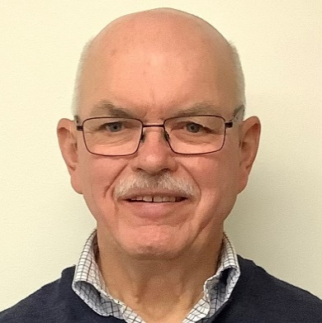
Tom and his wife Jan made New Hope their home in 2016 after moving from New York to Asheville to be near their daughter in Candler. After growing up on a dairy farm, Tom earned his BS in Agriculture Education at the University of Georgia and then served in the Peace Corps for seven years, first in Peru and then domestically as a recruiter. He later worked for Cornell University’s Quality Milk Program for over 26 years and then as a school bus driver, but he never lost his love of traveling and learning about other cultures. Tom has served the PC (USA) at both the local and Presbytery levels, and his interests include camping, hiking, and enjoying the outdoors. Contact Tom at tomwfife@gmail.com or (315) 528-8847.

Ann Moorefield (Class of 2024), Deacon
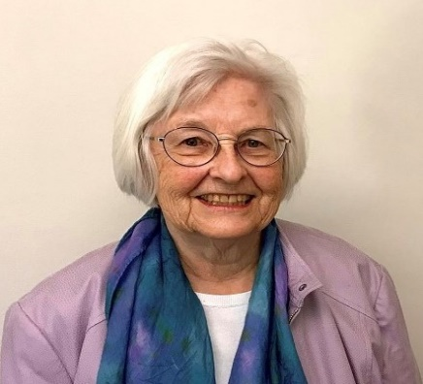
Ann is a lifelong Presbyterian who spent her first 8 years in Illinois; did most of her growing up in Darlington, SC; went to Wells College in Aurora, NY, and graduate school at the University of Michigan; then lived in Clinton, South Carolina, for more than 50 years. In the fall of 2019, Ann moved to Asheville from Clinton, where she had taught English and Women’s Studies at Presbyterian College and raised four amazing children in full cooperation with her beloved husband, David, a Presbyterian minister, who also taught at PC. She was active in church and community, especially in areas affecting women (Girl Scouts, League of Women Voters, feminist book club, etc.) Most recently within her church, she drew on what she had learned before David’s death to edit a brochure identifying community resources available to the homebound and their caregivers. She also became active within Stephen Ministry as a Stephen Leader. Now living at Deerfield Retirement Community, Ann is excited to be exploring new activities (such as pottery) and enjoying new friendships both there and at New Hope. She is looking forward to the time post Covid when all can interact in person and without masks. Contact Ann Moorefiled at admrfld@yahoo.com or (864) 923-3560.

*Bunk Spann (Class of 2023), Building & Grounds
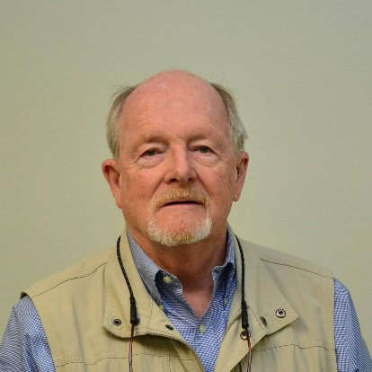
Bunk is a native of Greenville, South Carolina, and a lifelong Presbyterian. He has served as both a deacon and an elder in two other Presbyterian churches prior to moving to Asheville in 2013. A graduate of St. Andrews Presbyterian College, the Presbyterian School of Christian Education, and the University of Texas at Austin, Bunk taught graduate students in the department of Human Development and Counseling at Appalachian State University. He and his wife Nancy live at the Deerfield Episcopal Retirement Community and feel blessed to be members of the New Hope family. Bunk loves to dig in the dirt, so the Building and Grounds Committee keeps him happy. Contact Bunk at bunkspann@bellsouth.net or (828) 277-4040.

Clerk of Session
Nancy Spann (Class of 2025)
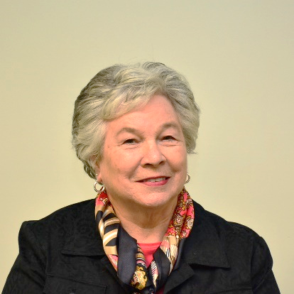
Nancy grew up in Statesville, North Carolina and moved to Asheville in 2013. She is a graduate of St. Andrews Presbyterian College, the University of Texas at Austin, and the University of North Carolina at Greensboro. Nancy spent her career at Appalachian State University, where she oversaw programs that helped freshmen become acclimated to college. A lifelong Presbyterian, Nancy served as a deacon and an elder at First Presbyterian Church in Boone. She is happy at New Hope, where she continues to be inspired by the worship services, fellowship, and open-minded discussions. Contact Nancy at spannng@appstate.edu or (828) 964-1493.

* Not a Member of the Session

George Bauernfeind, Treasurer
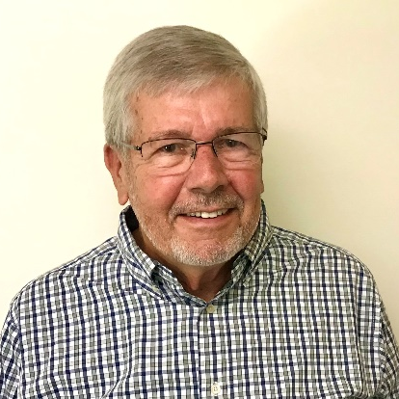
George joined New Hope as an affiliate member in 2022. He grew up in northern New Jersey and met his wife, Sally, in college. After he graduated from West Virginia University with an accounting degree, they moved to Washington, D.C., where George worked for several large CPA firms. During this time, he also earned his Master of Laws in Taxation degree from Georgetown University, and later worked for PricewaterhouseCoopers in Raleigh, NC, and Miami, FL. In 1989 he took the position of Vice President of Taxes for Humana, Inc. in Louisville, KY, and retired from this position in 2014. George and Sally’s six children and thirteen grandchildren are spread out across the country, in California, Boston, South Florida, South Carolina, and Raleigh, with their youngest son and his family here in Asheville. He is glad to be able to serve New Hope as our Treasurer. Contact George at ggb1005@gmail.com or (828) 651-8844.
*Russ Moxley, Faith Formation
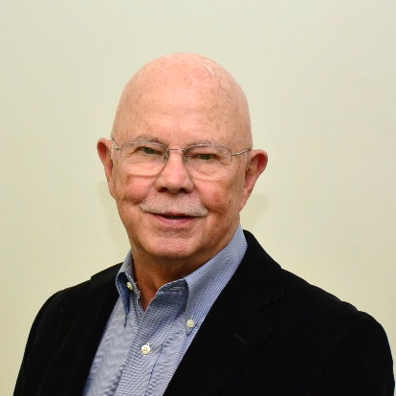
Russ is an ordained pastor in the United Methodist Church, and this year he will be serving as an Advisor to the Session, spending time at each Session meeting doing leadership training for our active elders. After first serving as Associate Pastor at University Park United Methodist Church in Dallas, Texas, Russ’s calling then turned to leadership development, and he was trained as a facilitator by the Center for Courage & Renewal, founded by Parker Palmer. Until 2002, Russ was a senior fellow at the Center for Creative Leadership and then served as a part-time faculty member there until 2018. Russ and his wife, Jean, live at Givens, and he continues to love baseball. Contact Russ at rmoxley@moxleyandassociates.com or (336) 210-3822.

Deacons
Bill Carpenter (Class of 2024), Deacon
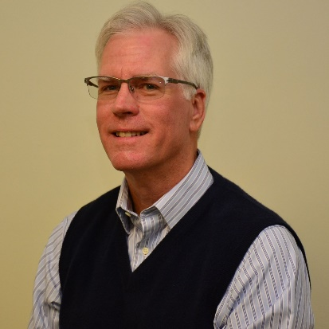
Bill is a lifelong Presbyterian and has served the church as an Elder, Deacon and Commissioner to the General Assembly. He is currently completing a six year term on the Presbytery’s Committee on Ministry. He is also the preferred push mower operator on the New Hope Building and Grounds Committee. Born and raised in Greenville, S.C., Bill graduated from UNC Charlotte and remained in the Charlotte area for 40 years before he and Terri retired to Asheville in 2015. Bill spent most of his career working in the criminal justice system, first as a deputy sheriff and then in a variety of roles with the state probation and parole division. After retiring from state service he worked in mental health case management and in sales with outdoor retailer REI. Bill and Terri have been married for the best part of 48 years. They have one daughter, who resides in West Asheville. Bill enjoys writing, reading, movies, hiking and Terri’s legendary cooking. Contact Bill at billcarpenter53@gmail.com or (704) 219-1893.
Janet Ferrell (Class of 2025), Deacon
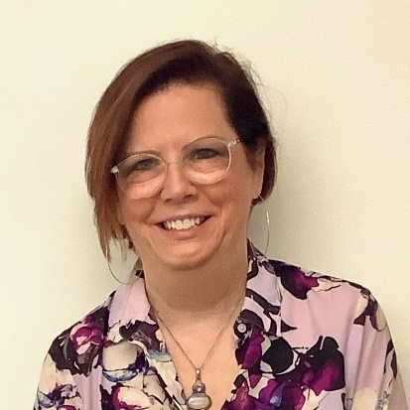
After growing up in Asheville, Janet was so happy to move back home in 2000 to make Asheville the family home again. She comes from a long line of Presbyterians on her mother’s side and over the years has attended various Presbyterian churches. Janet attended UNCA, where she met husband, Woody Ferrell, and graduated from UNCG with a degree in Fine Arts and continues to love that talent. In 2003, Janet found a new passion and started a nonprofit called First WNC to improve the lives of persons with disabilities, including their son, Austin. Janet and Woody have another son, Rush, who with his wife Caroline live in Janet’s childhood home. In addition to her work, Janet enjoys trips to her mother’s mountain home and quiet times at the beach. Contact Janet at janet@firstparentcenter.org or (828) 216-7745.

